Inner Triangle:
- Attach Guide to Inner Triangle: 3x M3-10 screw +washer+nut
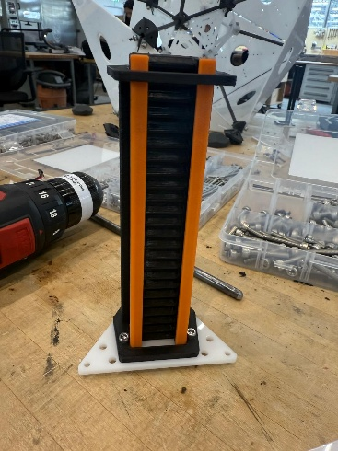
- Attach to frame: 3x M3-10 screw +washer
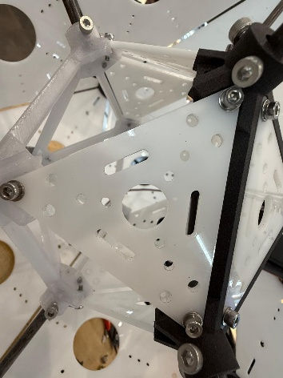

Outer Triangle (Frame):

- Attach servo mount to outer frame: 2x M3-16 screw +washer+nut
- Attach servo to servo mount: 2xM3-30 screw +washer (Bottom),2x M3-16 screw+washer+nut (TOP)
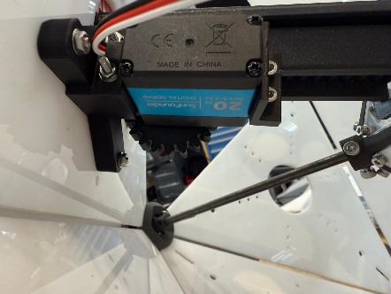
- Attach pinion to servo mount
- Attach rack and top plate:
  - Connect to power(everything out)
  - Press 0 in ardinuo
  - Connect rack to first three slots on the pinion
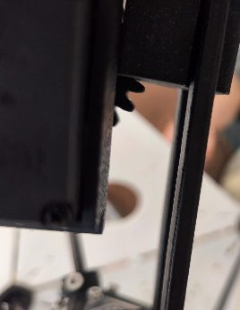
  - Press 255 in ardinuo

